In a SE38 program go to

Goto -Text Elements-> Text Symbols

\*Double click on Text Element to have following values in the Text Elements.

\*TEXT-001 = AA

\*TEXT-002 = DL

\*TEXT-003 = Airline Details

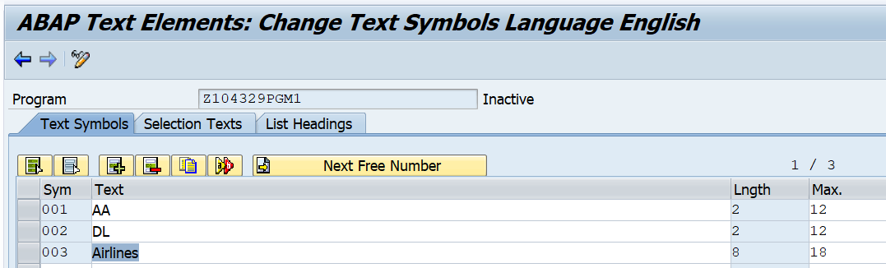

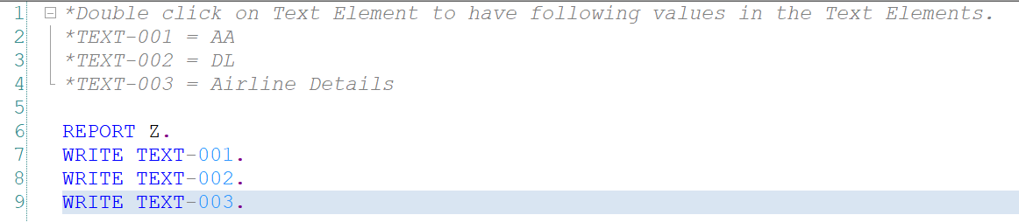

Execute the above program to view the results.

REPORT Z.

WRITE TEXT-001.

WRITE TEXT-002.

WRITE TEXT-003.